Lotus House
Child Protection Policy 2016

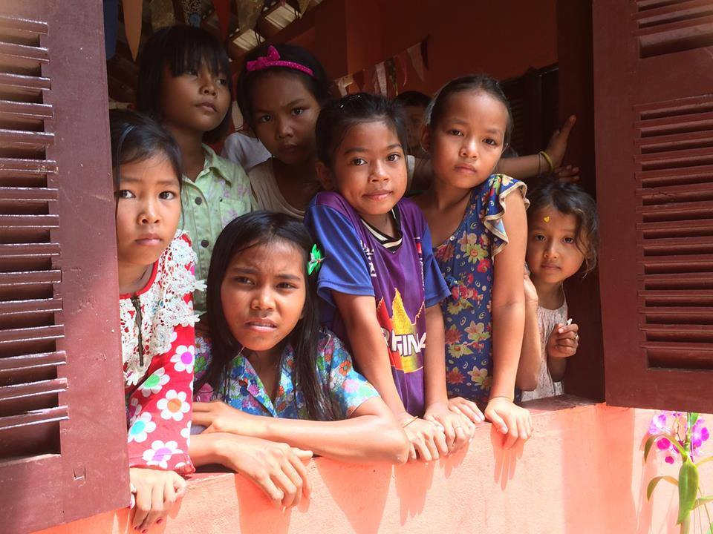

KINGDOM OF CAMBODIA
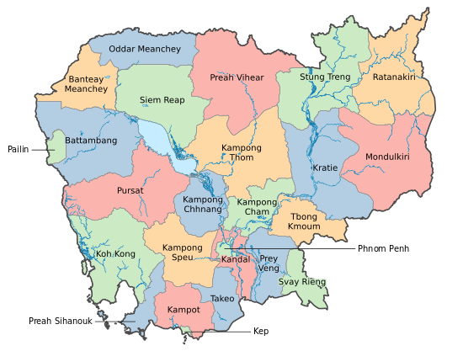
Just a few facts

Capital: Phnom Penh
Currency: Cambodia Reil
Population: 15.14 million
King: Norodom Sihamoni
Prime Minister: Hun Sen
Weather: Wet season (May – October) dry season (November – April)
Official language:Khmer
Religion: 95% Buddhist, Cham Muslim and Roman Catholic

Child Protection Policy

Purpose of this policy
The purpose of this policy is to ensure the protection and safety of children and the prevention of child exploitation and abuse of children. This Policy sets out general principles and guidelines, and specific obligations. Lotus House is committed to child safety and protection and will adhere to local and international child protection criminal laws, which prohibit the abuse and exploitation of children.
Statement of commitment
Lotus House is committed to the safety and well-being of all children. We support the rights of children and will act to ensure a child safe environment is maintained. Children have a right to survival, development, protection and participation, Lotus house will uphold these rights. Lotus house has a “Duty of Care” to provide children with an adequate level of protection against any form of abuse or harm including, risk of injury, child abuse, physical abuse, neglect, and sexual abuse while in our care. Lotus House believes that any form of child abuse and exploitation is unacceptable and will not be tolerated.
Definitions of abuse
Child abuse
Child abuse happens to male and female children of all ages and of any background. Child abuse includes physical, sexual, emotional, neglect as well as other forms of abuse that are deemed harmful to the growth of a child.
Physical abuse
This occurs when a person purposefully injures or threatens to injure a child. This may take the form of slapping, punching, shaking, kicking, burning, shoving or grabbing. The injury may also take the form of bruises, cuts, burns or fractures. It may also involve verbal abuse to the extent that it effects the child’s emotional growth.
Neglect
Neglect is defined as not meeting a child’s basic needs, including the failure to provide adequate health care, supervision, clothing, nutrition, housing as well as their physical, emotional, social, educational and safety needs.
Sexual abuse
Child sexual abuse occurs when an adult, adolescent or child uses their physical power or authority to involve a child in sexual activity including talking in a sexually explicit way that is not age or developmentally appropriate. Child sexual abuse can cause physical and emotional harm to a child.

Duty of Care
Declaration
Having children (persons 18 years and under) on Lotus House premises or engaged in Lotus House activities means we have, by law, a duty to care for them. Lotus House has established the following guidelines to properly supervise children under its duty of care. All staff, volunteers, and stakeholders, will be responsible for implementing these guidelines wherever applicable and they will be updated and reviewed regularly.
What is a Duty of Care?
A duty to take reasonable care to:
- Identify possible causes of harm; and
- Prevent harm from occurring
The duty of care of Lotus House staff, volunteers and stakeholders, is to identify and prevent potential causes of harm identified in these guidelines. All staff, volunteers and stakeholders must adhere to these guidelines.
Guidelines content
- Health and Safety
Lotus House staff, volunteers and stakeholders, have a duty at all times to ensure the safety of children in their care. Lotus House staff, volunteers and stakeholders, will comply with all requirements and will take all reasonable steps to predict any potentially harmful actions.
- Drug and Alcohol
Lotus House staff, volunteers and stakeholders are not permitted to consume or provide drugs or alcohol whilst undertaking Lotus House activities. Appropriate action will be taken if not adhered to.
- Violence
Lotus House will not tolerate aggressive or violent behaviour. Any staff member, volunteer or stakeholder, who behaves in this way will be asked to leave and appropriate action will be taken.

Scope of policy
Lotus house child protection policy applies to all persons who have contact with children through Lotus house programs, these persons include: teachers, staff, volunteers, visitors, sponsors, donors, board members, suppliers and consultants.

Code of Conduct for Working with Children
Introduction
This policy describes the standards of conduct and practice that Lotus House employees, volunteers and other stakeholders should follow when working with children
Purpose
The purpose of this policy is to protect and promote the interests of teachers, staff, volunteers and other stakeholders, and the children they work with. All adults who come into contact with children and young people, in their work, have a legal and moral duty to keep children and young people safe and to protect them from sexual, physical and emotional harm. The duty that rests on an individual is to ensure that all reasonable steps are taken to ensure the welfare of a child or young person is paramount.
Our objective is to:
- Create and maintain a protective environment for children
- Empower children who are active participants in Lotus House, and to listen to their views and respect what they have to say.
- Keep children safe by clarifying which behaviours constitute safe practice
- Assist adults working with children to work safely and responsibly and to monitor their own standards and practice
- Give a clear message that unlawful or unsafe behaviour is unacceptable and that, where appropriate, disciplinary or legal action will be taken
- Support safer recruitment practice
- Reduce the incidence of positions of trust being abused or misused.

Incident reporting
In the event of any incidents, suspicions or concerns, the event must be immediately reported to a person of authority and an investigation commenced. All cases of abuse will be investigated thoroughly in line with established procedures. All Lotus House staff will be made aware of the Child Reporting Process. An assessment of the allegation or event will be conducted and appropriate action will be taken, which can range from no-action, behavioural management, dismissal or police action.

Awareness
A Protective Behaviours Program will be introduced to all Lotus house students and staff and will be ongoing and up to date. This is to ensure all children understand about their rights, safety and protection, and feel comfortable about speaking to someone if they have any concerns. Children will be made aware of an adult to whom they can talk to without prejudice, and discuss any concerns.

Use of child images
Lotus House will always respect the wishes of the children and their parents regarding the use of images. We ask that you seek permission to use images of children, and that images including videos are never used in a way that is undignified, places children at risk, or comprises their safety.

Safer recruitment procedures
Procedures for the recruitment of Lotus House staff and volunteers will undertake appropriate child protection measures. We share a common objective to help keep children safe by contributing to:
• Providing a safe environment for children; and
• Prevent unsuitable people working with children
This will be implemented through a screening process where we will require national police checks (or equivalent standard) to be conducted on all staff, both expatriate and Cambodian. References will need to be supplied and an interview process will take place. All of our staff and volunteers must agree to abide by our code of conduct.
All personal information considered or recorded will respect the privacy of the individuals involved, whether they be staff or volunteers unless there is a risk to someone’s safety.

CODE OF CONDUCT CONTRACT

All Lotus House staff and volunteers must agree to abide by our code of conduct
As an employee, contractor or volunteer, I, _____________________________ am responsible for promoting the safety and wellbeing of children and young people in this workplace.

I will not:
- Subject a child to any form of corporal punishment, social isolation, immobilisation, sexual suggestion, offence or misconduct.
- Direct a child to perform in a sexually provocative or unsafe manner.
- Communicate with a child in ways that are likely to humiliate, frighten or distress a child.
- Use tobacco products or possess or be under the influence of alcohol or illegal drugs at any time while working with children.
- Develop any ‘special’ relationships with children that could be seen as grooming/favouritism such as the offering of gifts or special treatment.
- Do things of a personal nature that a child can do for themselves, such as toileting or changing clothes.
I will:
- Treat children with respect and be a positive role model in my conduct with them.
- Communicate with the children in an age appropriate and realistic manner.
- Set clear boundaries about appropriate behaviour between myself and a child.
- Only have physical contact with a child in ways which are appropriate to my professional or agreed role and responsibilities.
- Be willing to listen and respond appropriately to a child’s views and concerns.
- Respond quickly, fairly and transparently to any serious complaints made by a child or related to a child.
- Abide by reporting obligations in relation to Lotus House Incident Reporting
- Abide by Lotus House Child Safety Policy

I agree to abide by Lotus House Code of Conduct.
Name: …………………………………………………………………………………
Signature: …………………………………………………………………………..
Date: ………………………………………………………………………………….

